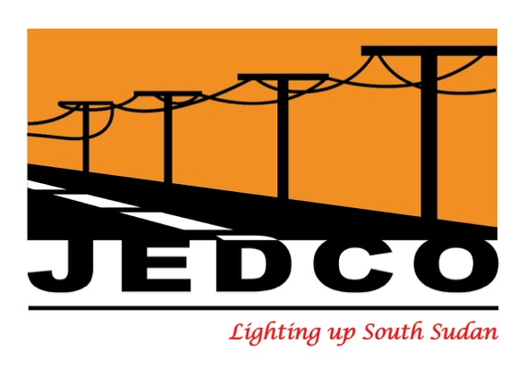

MEDIA RELEASE

NO SHUT DOWN OF EZRA POWER PLANT
SOUTH SUDANESE GOVERNMENT INTERVENES TO KEEP EZRA CONSTRUCTION AND DEVELOPMENT GROUP’S JUBA POWER PLANT OPERATIONAL
Juba, South Sudan, January 11, 2021 – A last-minute solution has been found to stop plans by the Ezra Construction and Development Group to shut down the Juba power plant. The Government of the Republic of South Sudan has intervened, and all stakeholders are now urgently working together to make sure this drastic action never happens in the future.
Following this latest intervention, the Juba Electricity Distribution Company (JEDCO) will NOT disrupt any of its services and will continue to provide all its customers with a safe and reliable electricity supply.
The Government, Ezra and JEDCO assure all the citizens of South Sudan that they are dedicated to helping to develop the country to benefit all who live here.

Contact:
Email: info@jedcopower.com
https://www.facebook.com/JEDCOJuba
www.jedcopower.com

